 [Translated from Korean to English - www.onlinedoctranslator.com](https://www.onlinedoctranslator.com/en/?utm_source=onlinedoctranslator&utm_medium=docx&utm_campaign=attribution)

**How to download ACQ(CBAMD) TMS320F28377S F/W**

20230502

1. Preparations
   1. JTAG tool equivalent to XDS510 or XDS560 v2
      1. XDS510: Downloadable for CCS 8.x version or lower
      2. XDS560 v2: Available for download in CCS 12.x version
   2. CCS 8.x or CCS 12.x (latest version)
2. How to install
   1. If the product you have is XDS510, install CCS 8.x version or lower.
   2. If the product you have is XDS560 v2, you can install the latest version of CCS 12.x.
3. download method
   1. XDS510 (XDS560 v2) to USB
      1. 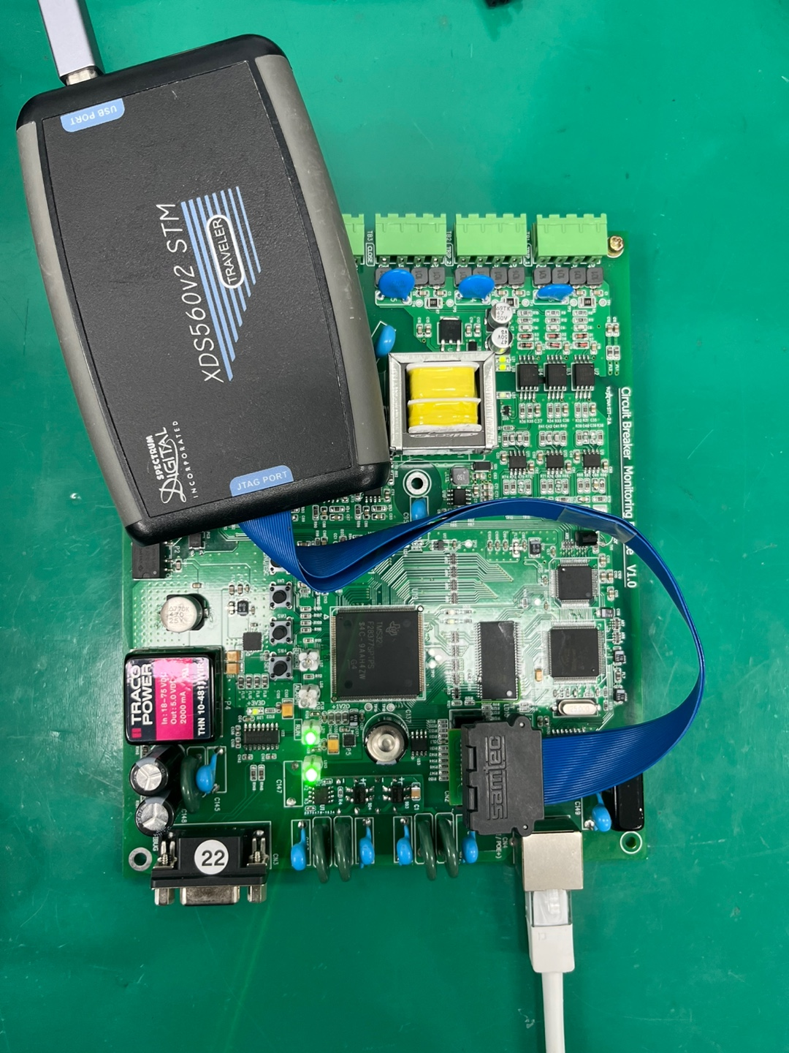
   2. CCS run
      1. 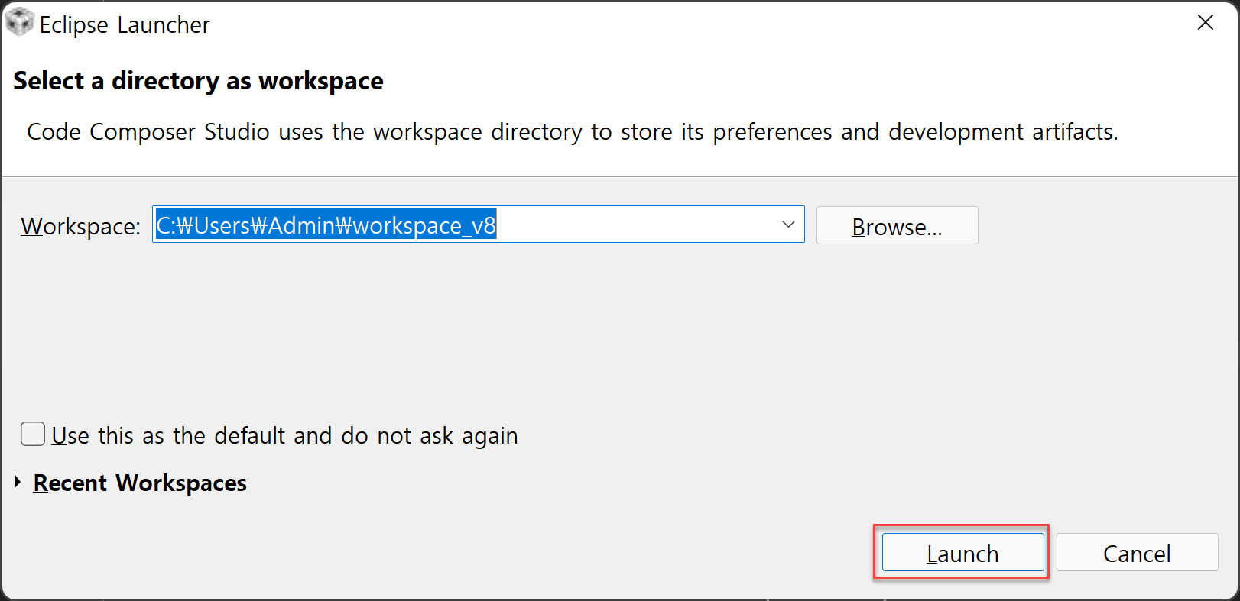
   3. View -> Target Configurations
      1. 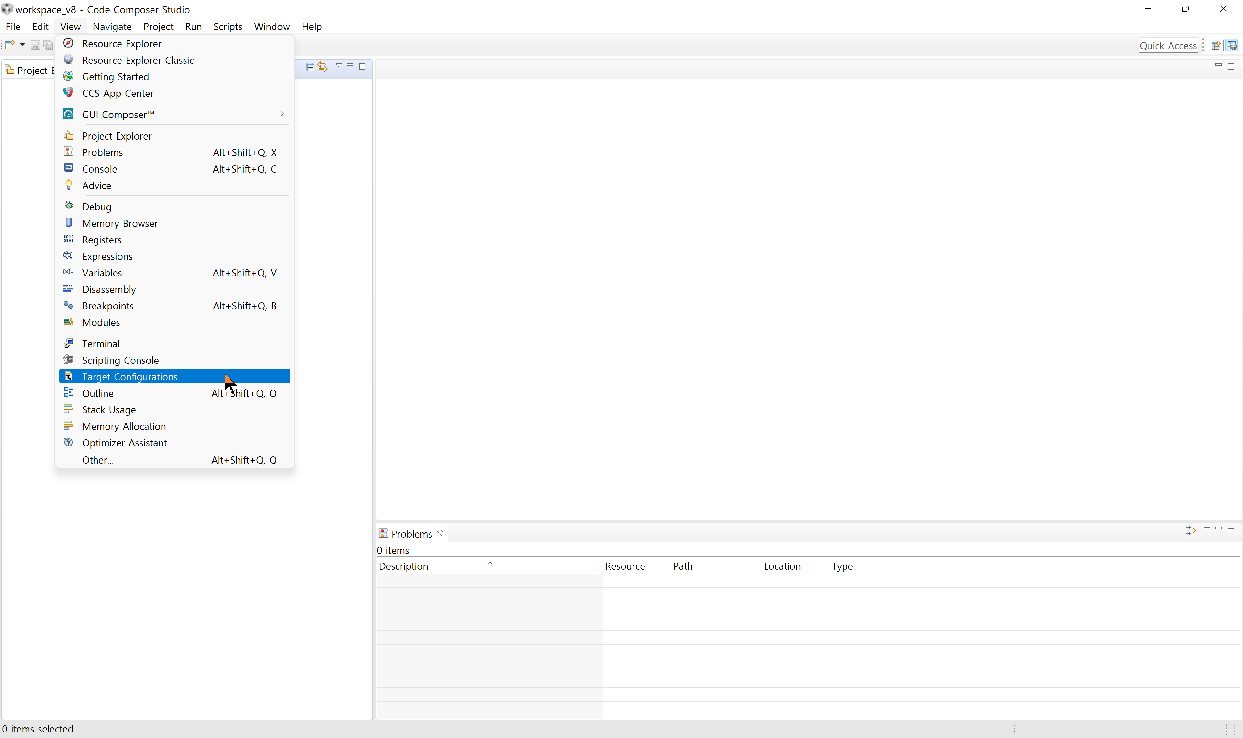
   4. Target Configurations Window -> Right-click User Defined -> New Target Configuration
      1. 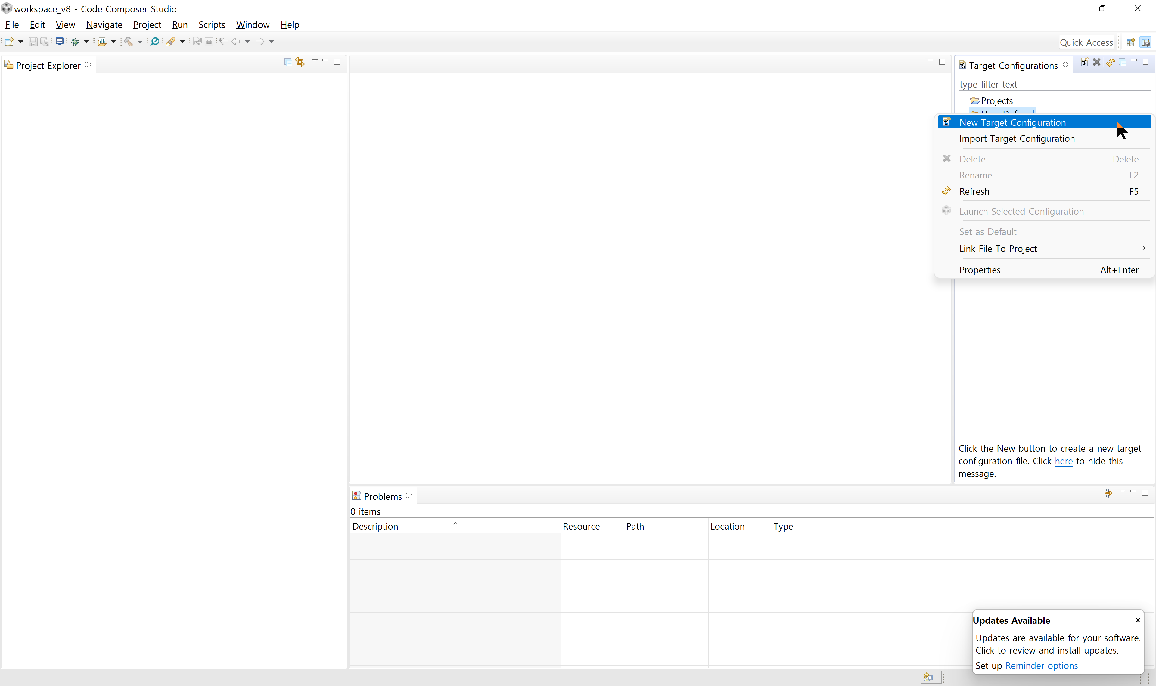
   5. Create TMS320F28377S.ccxml file
      1. 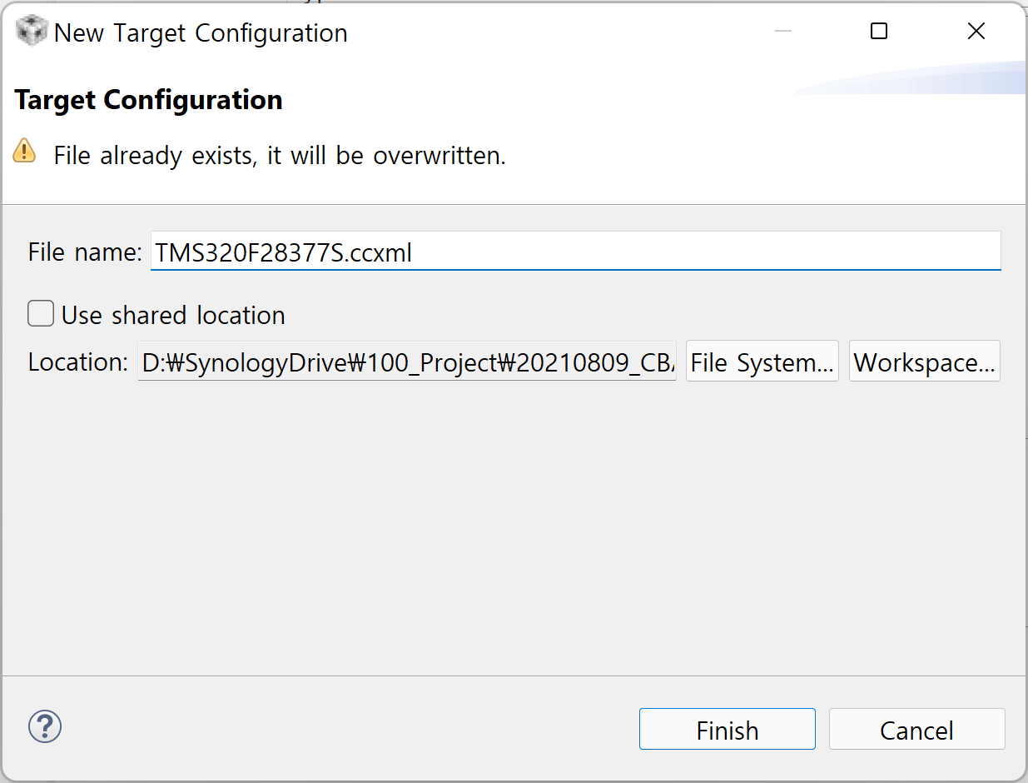
   6. TMS320F28377S.ccxml Save
      1. Select XDS510 or XDS560 // You need to select differently depending on the manufacturer and model name.
      2. Select TMS320F28377S
      3. Click Save to save
      4. 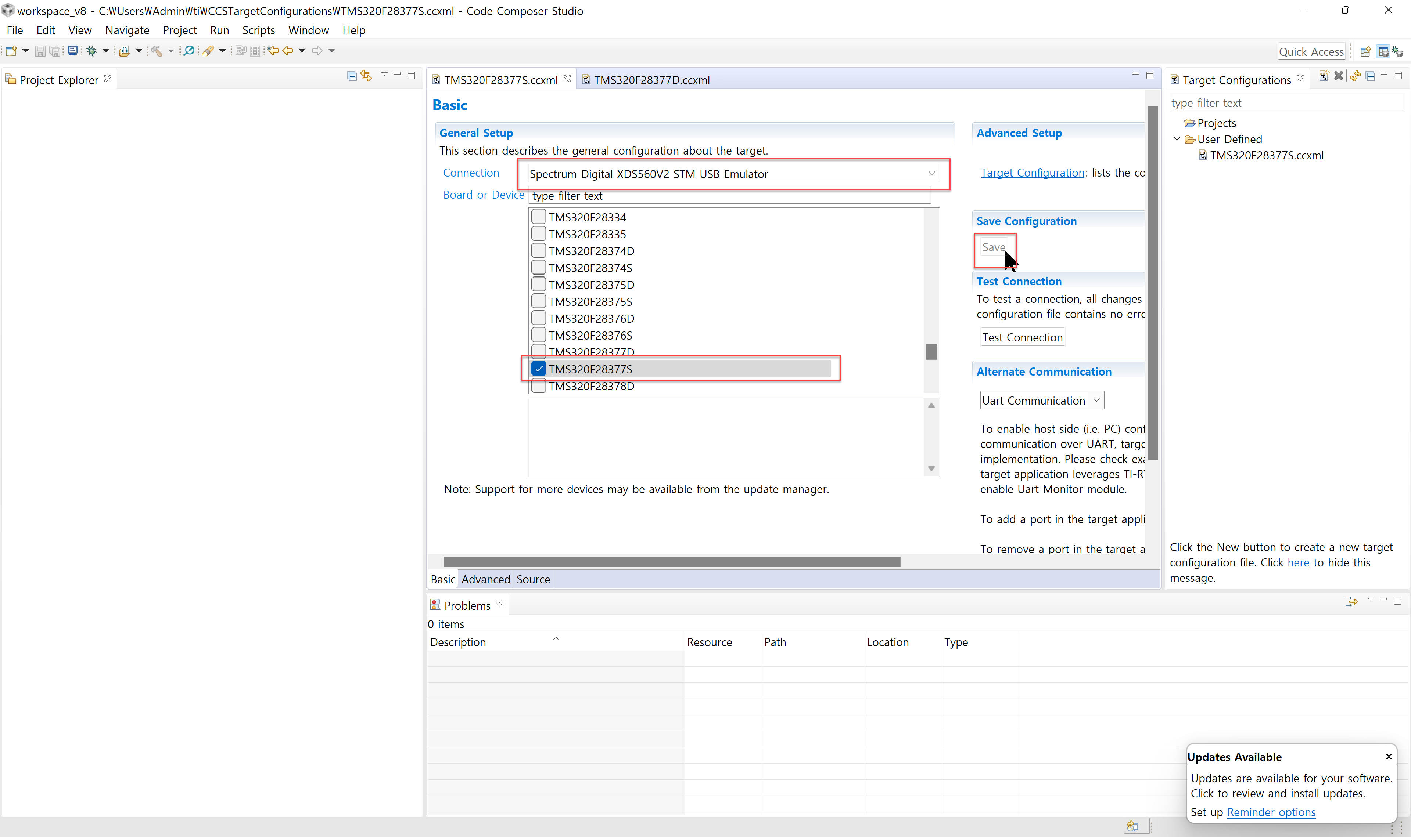
   7. Launch Selected Configuration
      1. 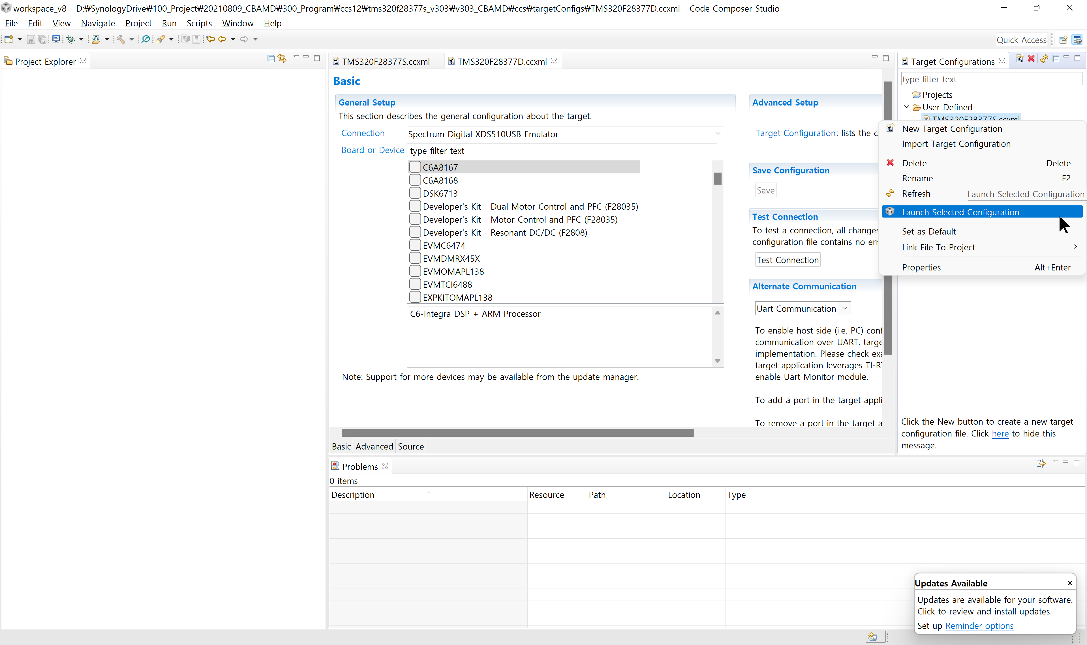
      2. 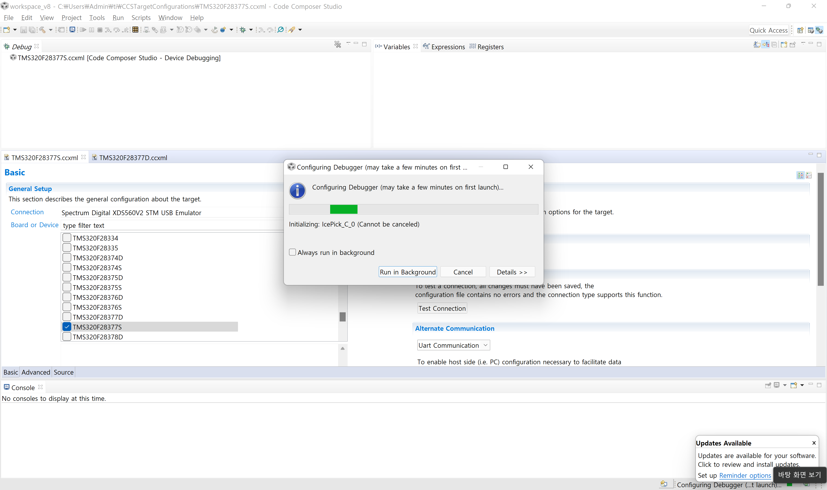
   8. Debug window -> right click spectrum Digital XDS560V2 STM USB Emulator_0/C28xx_CPU1 (Disconnected : Unknown) -> Connect Target
      1. 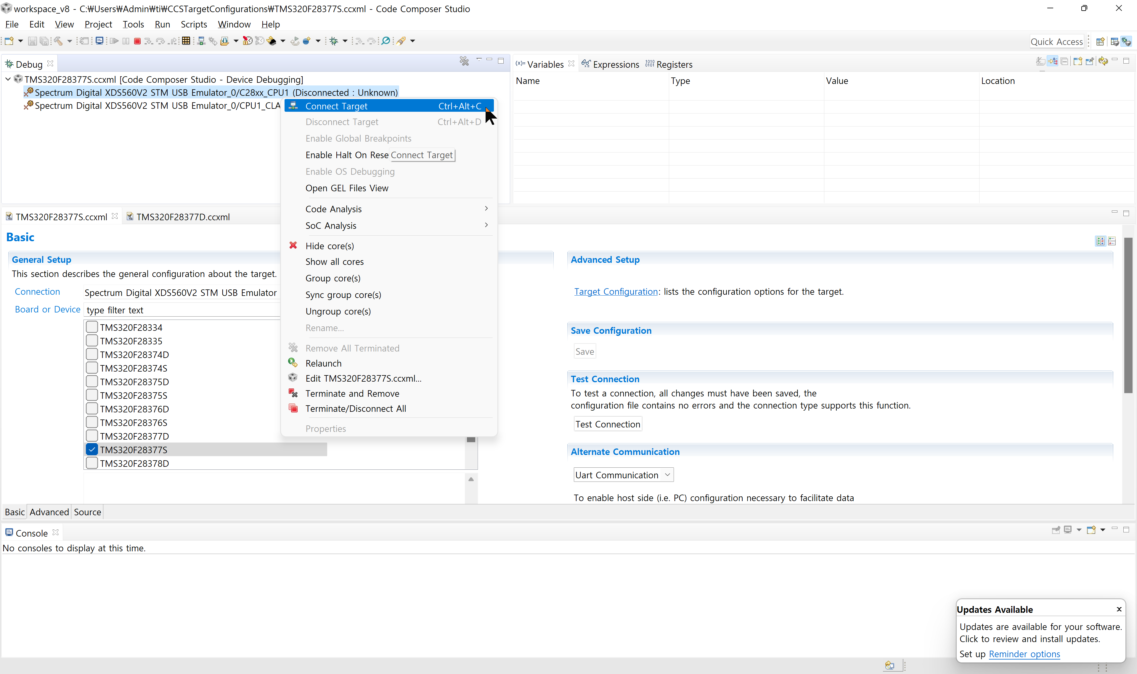
   9. Run -> Load -> Load Program -> Browse -> Select v303_CBAMD.out -> Open -> OK
      1. 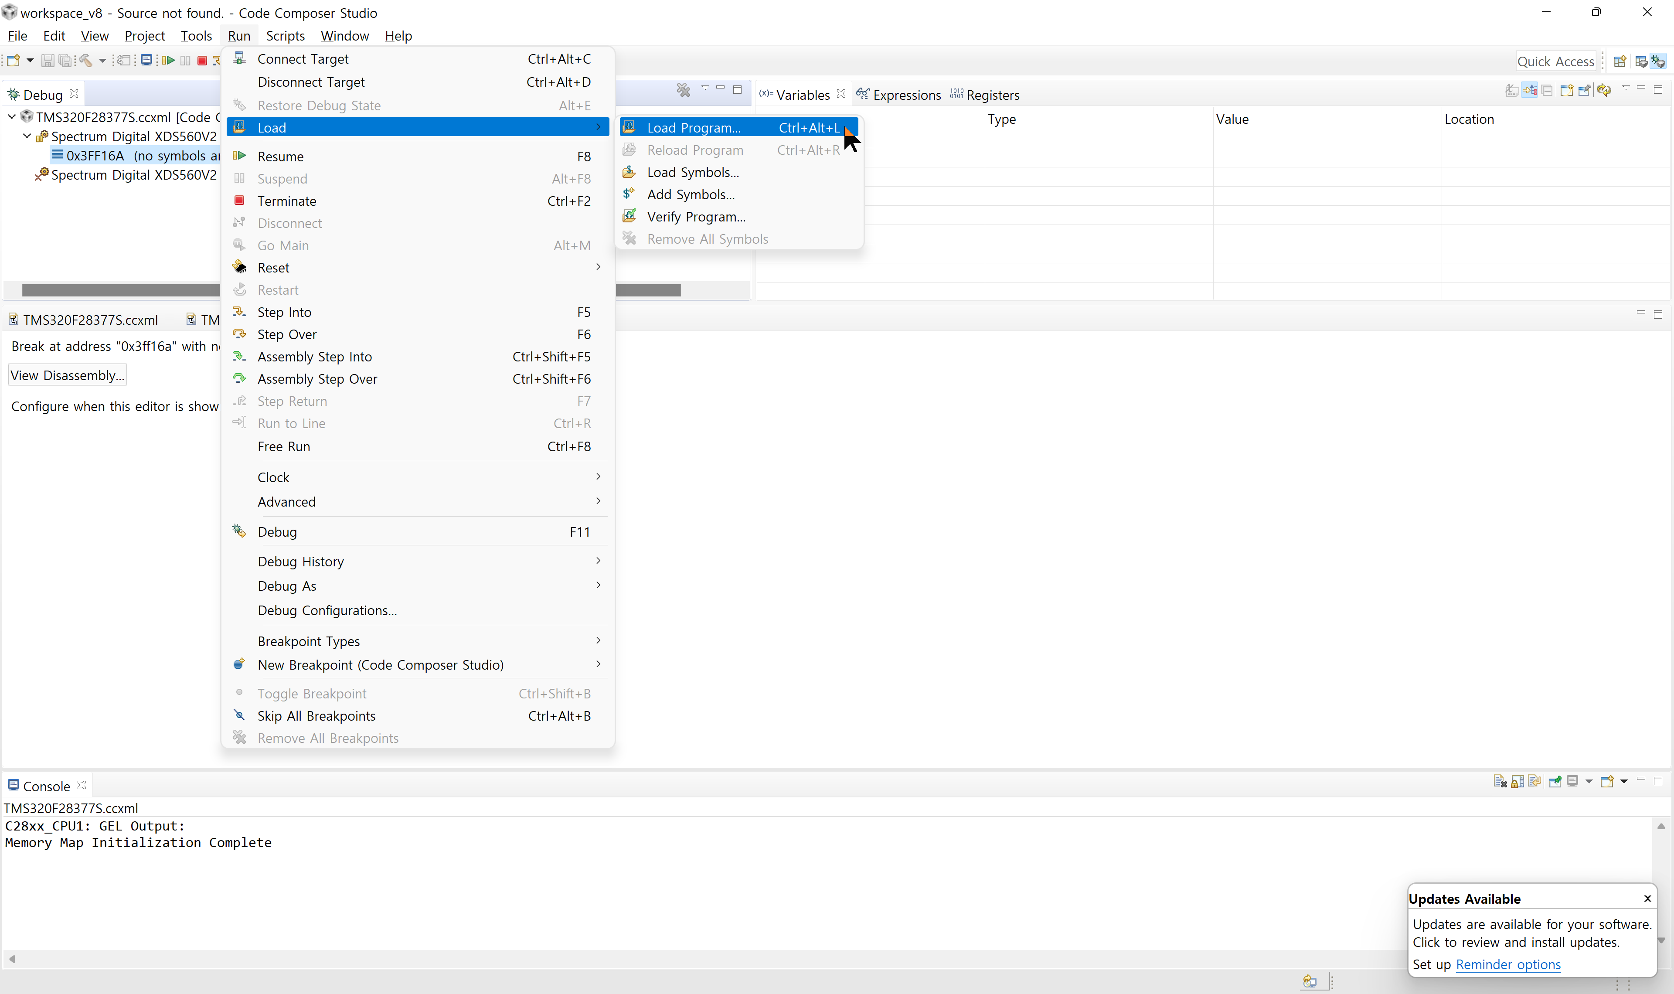
      2. 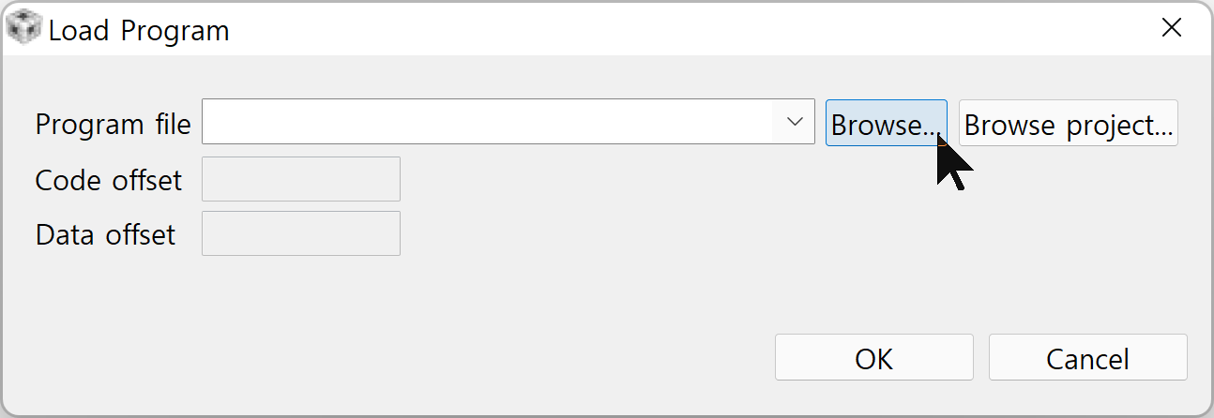
      3. 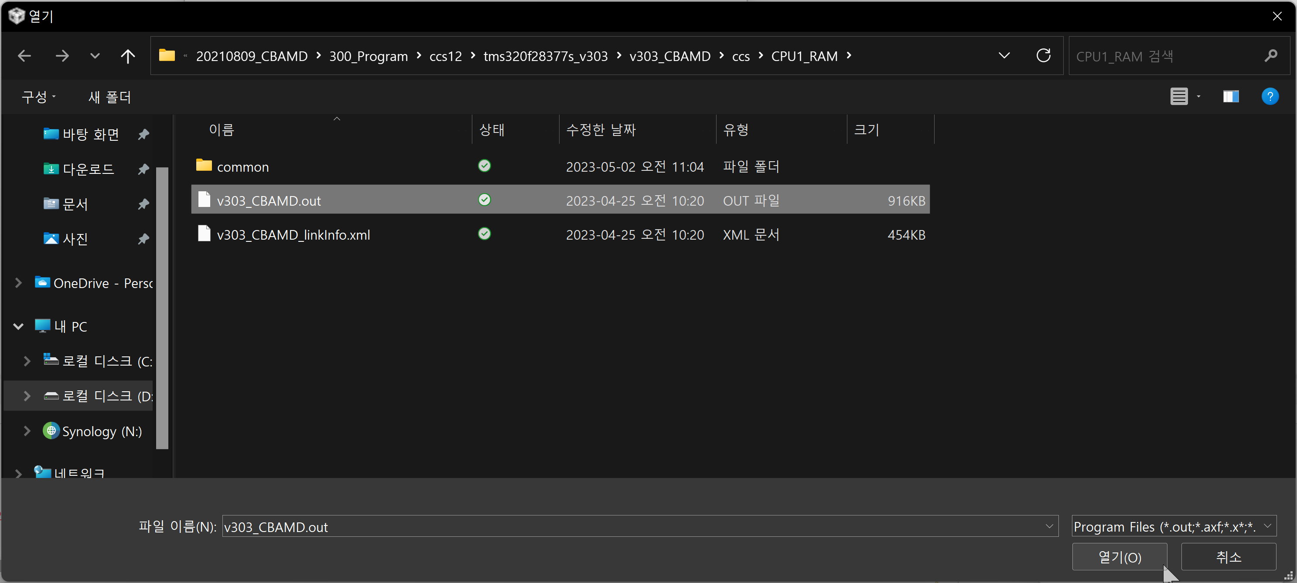
      4. 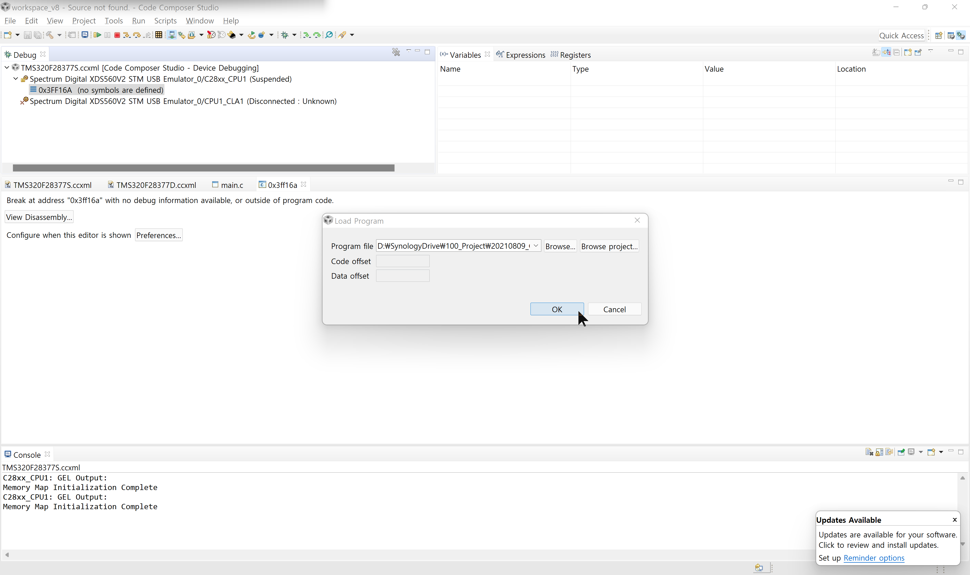
   10. Click the square red icon
       1. 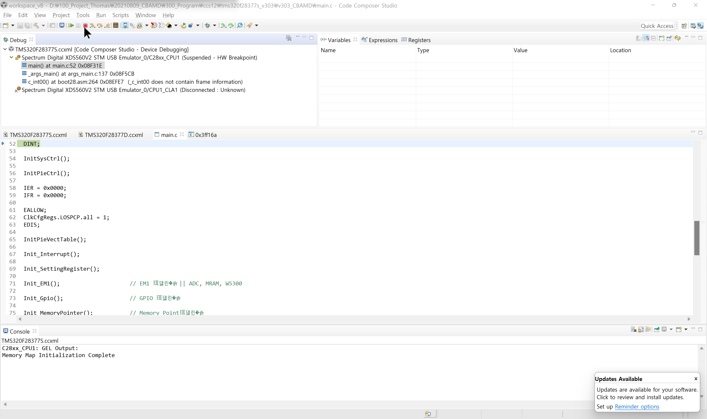
   11. After power off -> on operation, check the version on the initial screen of Debug
       1. 2023.05.02 v 1.01